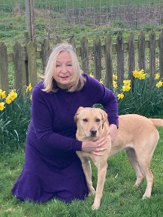
Report from Councillor Liz Vickers (Fakenham Lancaster South Ward) 25 October 2023.
Meetings Attended
I attended two meetings of North Norfolk District Council’s Development Committee and a meeting of the Overview and Scrutiny Committee.
Fast Food Restaurant
Planning advice has been requested for a drive through restaurant proposed on the land behind Lidl supermarket.
Hall Close
This is an ongoing case. There is an uneven footpath that I am told has caused several tripping incidents. I met a representative from Flagship on site today, along with several residents. Hopefully this will be resolved shortly.
The Drift
At the request of residents, I am monitoring heavy lorry traffic in The Drift. I have discussed this with local employers and asked them to request that their drivers do not use The Drift as a cut through to Holt/Norwich Roads. On behalf of residents I have asked Highways if we can implement a HGV ban.
Mapping Vacant Shops
At the request of the Chamber of Trade, I have mapped vacant shops to establish who the landlords are. I have had some success, and I am meeting a landlord shortly. I will pass this information to NNDC’s Economic Development Team for their assistance.
Community Orchard
I am delighted by the Community Orchard proposal for Millenium Park. A huge thank you to Fakenham Town Council for starting and developing this project which will be a positive enhancement to the park.
The Maltings
The residents of the Maltings care home hosted a Macmillan coffee morning. I attended with our Mayor, Angela Glynn. We were given a warm welcome and lots of delicious cake. It was a pleasure to meet the residents and hear their life stories.

